**ASSIGNMENT 1 WEB LAB PROGRAMS**

**NAME:Chetan S A**

**USN: ENG18CS0073**

**CLASS: B SEC**

**PROGRAM:1**

<!DOCTYPE html>

<html>

<head>

<title>1st page</title>

</head>

<body>

<h1>charcter entity examples</h1>

<ol>

<li>the address of variable reprsented as &a</li>

<li>5&lt6</li>

<li>10&gt8</li>

<li>this reprsents &quotDouble quotes&quot</li>

<li>this represents &#39Single quotes&#39</li>

<li>one fifth of fraction represented as &frac12</li>

<li>the degree is represented as &deg </li>

<li>the cuurencey in europe is &#8364 </li>

<li>&copy jan 2021,Your Name.All copyrights reserved</li>

</ol>

</body>

</html>

**OUTPUT:**

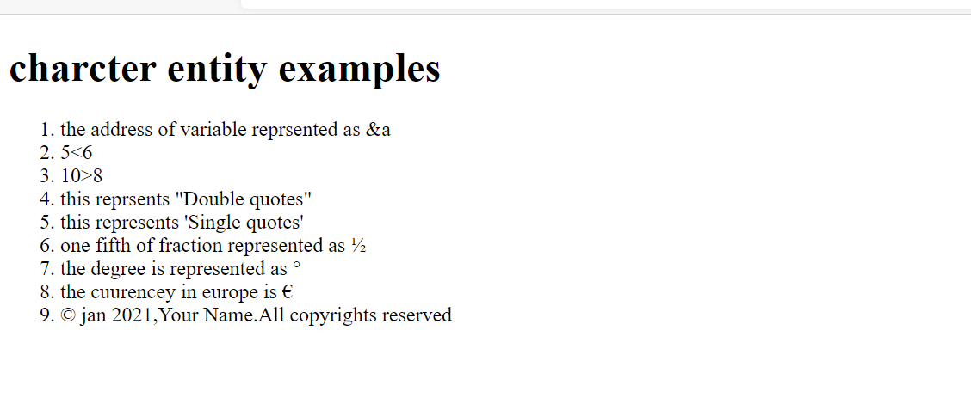

**PROGRAM2:**

<!DOCTYPE html>

<html>

<style>

</style>

<head>

<title>2nd question</title>

</head>

<body class ="link">

<button style="background-color: yellow; height: 30px;"><a href="">About</a></button>

<button style="background-color: yellow; height: 30px;"><a href="">Introduction</a></button>

<button style="background-color: yellow; height: 30px;"><a href="">Education</a></button>

<button style="background-color: yellow; height: 30px;"><a href="">Contact Us</a></button>

</body>

</html>

**OUTPUT:**

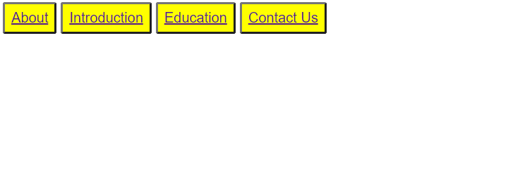

**PROGRAM3(A):**

<!DOCTYPE html>

<html>

<style>

.body{

background-color: black;

text-align: center;

}

</style>

<head>

<title>3rd page</title>

</head>

<body class="body">

<h1 style="color: white;">This is Heading</h1>

<h5 style="color: white; ">This is Paragraph</h5>

<img src="C:\Users\tarun\OneDrive\Desktop\web_programming\assignment\images\3.png" width="250" height="300">

</body>

</html>

**OUTPUT:**



**PROGRAM3(B):**

<!DOCTYPE html>

<html>

<style>

.hobbies {

display: flex;

justify-content: space-around;

align-items: center;

}

</style>

<head>

<title>4th page</title>

</head>

<body>

<h1 style="text-align: center;">List Of My Favorite Hobbies</h1>

<div class="hobbies">

<div>

<ul>listening songs</ul>

<img src="C:\Users\tarun\OneDrive\Desktop\web_programming\assignment\images\songs.png" width="250px" height="200px" style="border-style: solid;">

</div>

<div>

<ul>going to gym</ul>

<img src="\C:\Users\tarun\OneDrive\Desktop\web_programming\assignment\images\gym.png" alt="gym" style="width:250px; height:200px; border-style: solid;">

</div>

<div>

<ul>stock market</ul>

<img src="C:\Users\tarun\OneDrive\Desktop\web_programming\assignment\images\stockmarket.png" width="250px" height="200px" style="border-style: solid;">

</div>

<div>

<ul>surfing internet</ul>

<img src="C:\Users\tarun\OneDrive\Desktop\web_programming\assignment\images\internet.png" width="250px" height="200px"style="border-style: solid;">

</div>

</div>

</body>

</html>

**OUTPUT:**

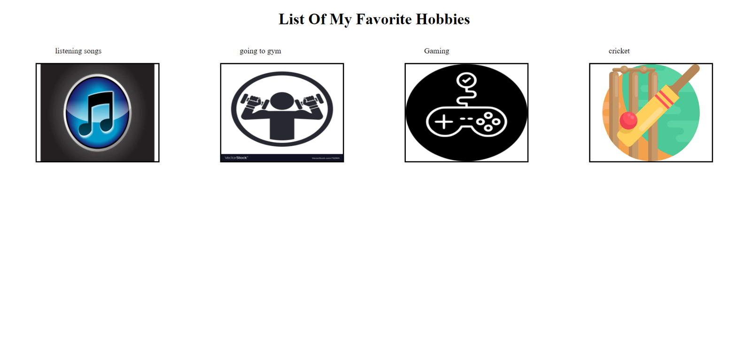

**PROGRAM 4:**

<!DOCTYPE html>

<html>

<style>

.body{

font-family: -apple-system, BlinkMacSystemFont, 'Segoe UI', Roboto, Oxygen, Ubuntu, Cantarell, 'Open Sans', 'Helvetica Neue', sans-serif;

background-color: orange;

}

</style>

<head>

<title>8th page</title>

</head>

<body class="body">

<h1 style="text-align: center; ">Enter Your Details</h1>

<form action="" class="from">

<label for ="fname">FIRST NAME</label>

<input type="text" id="fname" name="first name" max="20">

<br>

<label for="usn">USN</label>

<input type="text" id="usn" name="usn" max="20">

<br>

<br>

<label for="select year">SELECT YEAR</label>

<br>

<input type="radio"><label for="FIRST">FIRST</label>

<br>

<input type="radio"><label for="SECOND">SECOND</label>

<br>

<input type="radio"><label for="THIRD">THIRD</label>

<br>

<input type="radio"><label for="FOURTH">FOURTH</label>

<br>

<br>

<label for="select subjects">SELECT SUBJECTS</label>

<br>

<input type="radio"><label for="web programming">WEB PROGRAMMING</label>

<br>

<input type="radio"><label for="DESIGN AND ANALYSIS OF ALOGORITHMS">DESIGN AND ANALYSIS OF ALOGORITHMS</label>

<br>

<input type="radio" for = "signals and systems"><label>SIGNALS AND SYSTEMS</label>

<br>

<button><a href="another.html">submit to another web page</a></button>

</form>

</body>

</html>

**OUTPUT:**

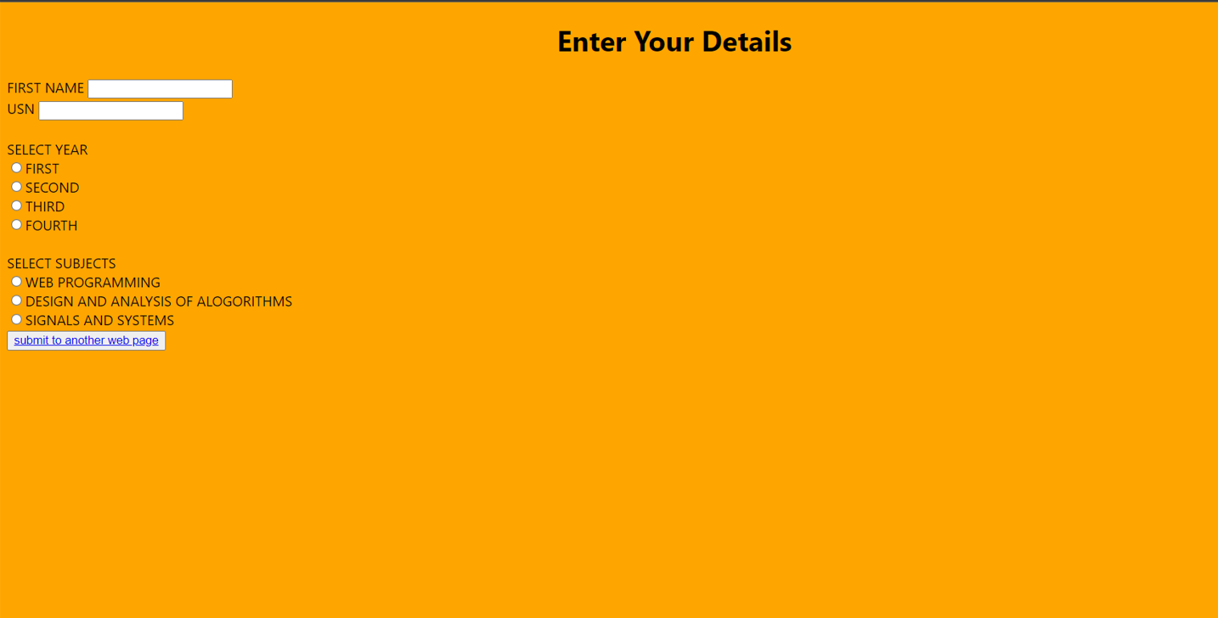

**PROGRAM 5:**

<!DOCTYPE html>

<html>

<style>

ol.a {list-style-type: upper-roman;}

ol.b {list-style-type: decimal;}

ol.c {list-style-type: upper-roman;}

ol.d {list-style-type: lower-roman;}

</style>

<head>

<title>5th page</title>

</head>

<body>

<h1 style="text-align: center;">The ol type attribute</h1>

<ol class ="a">

<li>coffee</li>

<li>Tea</li>

<li>Milk</li>

</ol>

<ol class ="b" start="50">

<li>coffee</li>

<li>Tea</li>

<li>Milk</li>

</ol>

<ol class ="c" start="6">

<li>coffee</li>

<li>Tea</li>

<li>Milk</li>

</ol>

<ol class ="d" start="6">

<li>coffee</li>

<li>Tea</li>

<li>Milk</li>

</ol>

</body>

</html>

**OUTPUT:**

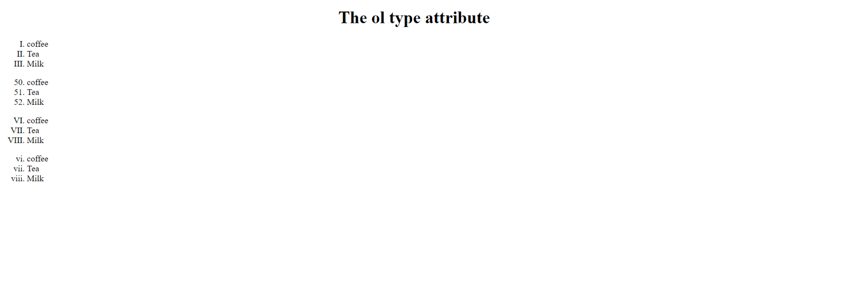

**PROGRAM 6:**

<!DOCTYPE html>

<head>

<style>

.step {

border: 2px solid black;

font-size: 18px;

height: 80px;

}

.step:nth-child(1)

{width: 120px; margin-left: 600px; margin-top: 100px;

}

.step:nth-child(2)

{width: 240px; margin-left: 480px;

}

.step:nth-child(3)

{width: 340px; margin-left: 380px;

}

.step:nth-child(4)

{width: 420px; margin-left: 300px;

}

</style>

</head>

<body>

<div class='step'><br>The<br>summit!</div>

<div class='step'><br>We're close to the end.</div>

<div class='step'><br>The second step uses a different foot.</div>

<div class='step'><br>The first step is the hardest.</div>

</body>

</html>

**OUTPUT:**

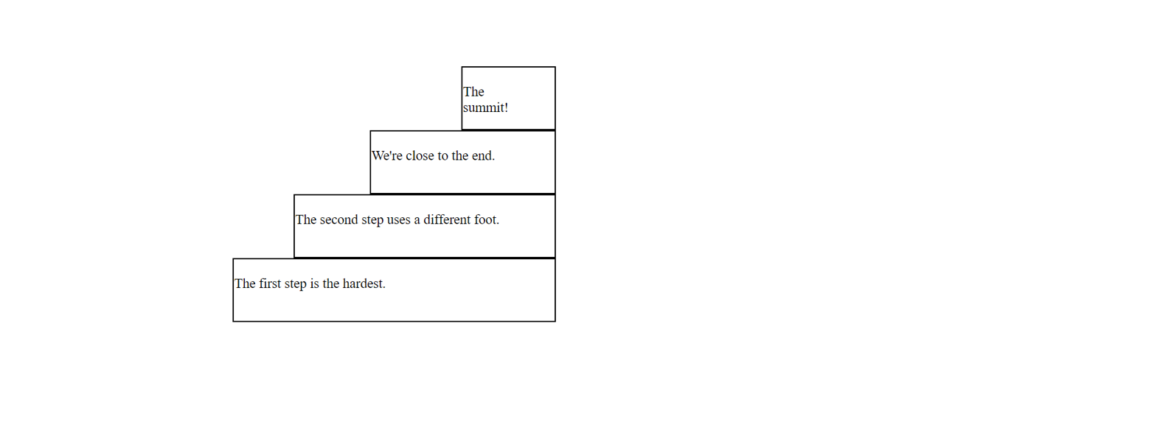

**PROGRAM 7:**

<!DOCTYPE html>

<html>

<style>

</style>

<head>

<title>6th page</title>

</head>

<body>

<div class="a">

<table style="width: 100%;">

<tr style="width: 100%;">

<th style="padding-right: 30%;">Day</th>

<th style="padding-right: 30%;">image</th>

<th style="padding-right: 30%;">Article Name</th>

<th style="padding-right: 30%;">Auther</th>

<th style="padding-right: 30%;">Words</th>

<th style="padding-right: 30%;">Shares</th>

</tr>

<tr >

<td>1</td>

<td><img src="C:\Users\tarun\OneDrive\Desktop\web_programming\assignment\images\3.png" width="250" height="100"></td>

<td>Bootstrap 4 CDN and starter template</td>

<td>Critina</td>

<td>913</td>

<td>2846</td>

</tr>

<td>2</td>

<td><img src="C:\Users\tarun\OneDrive\Desktop\web_programming\assignment\images\internet.png" width="250" height="100"></td>

<td>Bootstrap grid 4 tutorials and examples</td>

<td>cristina</td>

<td>1434</td>

<td>3417</td>

</tr>

</table>

</div>

</body>

</html>

**OUTPUT:**

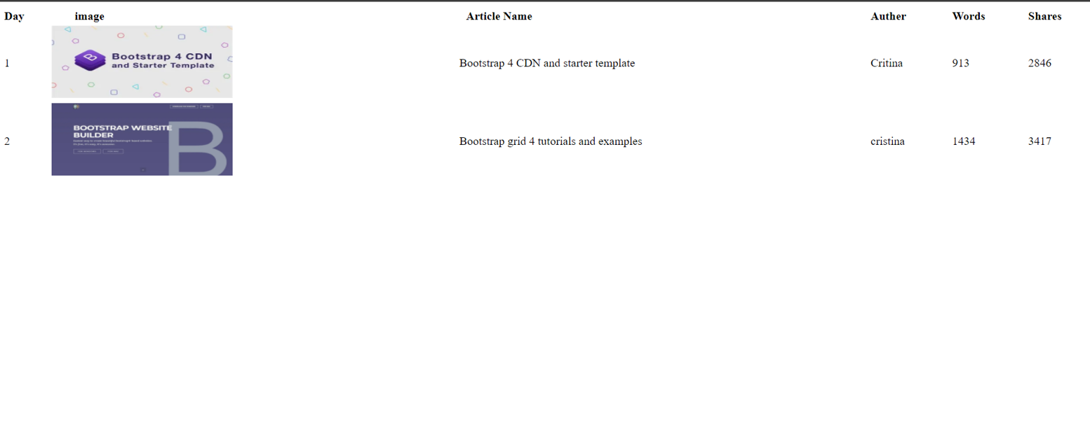

**PROGRAM8:**

<!DOCTYPE html>

<html>

<link rel="stylesheet" type = "text/css" href="8.css">

<head>

<title>8th page</title>

</head>

<body class="body">

<h1 style="text-align: center; ">Enter Your Details</h1>

<form action="" class="from">

<label for ="fname">FIRST NAME</label>

<input type="text" id="fname" name="first name" max="20">

<br>

<label for="usn">USN</label>

<input type="text" id="usn" name="usn" max="20">

<br>

<br>

<label for="select year">SELECT YEAR</label>

<br>

<input type="radio"><label for="FIRST">FIRST</label>

<br>

<input type="radio"><label for="SECOND">SECOND</label>

<br>

<input type="radio"><label for="THIRD">THIRD</label>

<br>

<input type="radio"><label for="FOURTH">FOURTH</label>

<br>

<br>

<label for="select subjects">SELECT SUBJECTS</label>

<br>

<input type="radio"><label for="web programming">WEB PROGRAMMING</label>

<br>

<input type="radio"><label for="DESIGN AND ANALYSIS OF ALOGORITHMS">DESIGN AND ANALYSIS OF ALOGORITHMS</label>

<br>

<input type="radio" for = "signals and systems"><label>SIGNALS AND SYSTEMS</label>

<br>

<button><a href="another.html">submit to another web page</a></button>

</form>

</body>

</html>

**OUTPUT:**

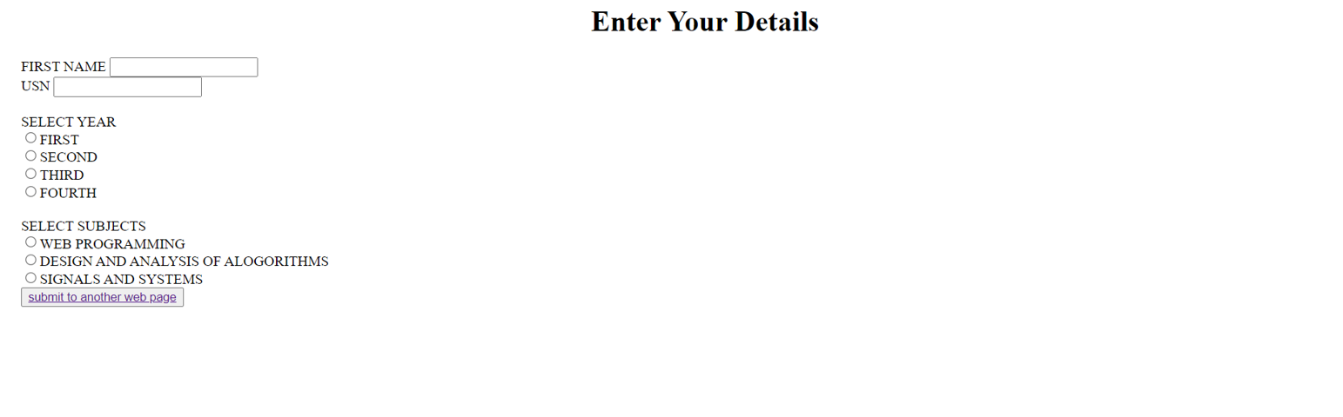

**PROGRAM 8B:**

<!DOCTYPE html>

<html>

<link rel="stylesheet" type = "text/css" href="8.css">

<head>

<title>another web page</title>

</head>

<body class="one" >

<h1>SUBMITTED FORM DATA</h1>

</body>

</html>

**OUTPUT:**



**PROGRAM 9:**

<!DOCTYPE html>

<head>

<link rel="stylesheet" href="9.css">

</head>

<body>

<div class="container">

<div class="title">Event Registration Form</div>

<form action="#">

<div class="user-details">

<div class="input-box">

<span class="details">First Name</span>

<input type="text" placeholder="firstname">

</div>

<div class="input-box">

<span class="details">Surname Name</span>

<input type="text" placeholder="surname">

</div>

<div class="input-box">

<span class="details">Email</span>

<input type="text" placeholder="e.g. abc@gmail.com">

</div>

<div class="input-box">

<span class="details">Phone</span>

<input type="text" placeholder="phone number">

</div>

<div class="input-box">

<span class="details">Age</span>

<input type="number">

</div>

<div class="input-box">

<span class="details">Password</span>

<input type="text" placeholder="password">

</div>

<div class="input-box">

<span class="details">Confirm Password</span>

<input type="text" placeholder="re-enter password">

</div>

</div>

<div class="gender-details">

<input type="radio" name="gender" id="dot-1">

<input type="radio" name="gender" id="dot-2">

<input type="radio" name="gender" id="dot-3">

<span class="gender-title">Gender</span>

<div class="category">

<label for="dot-1">

<span class="dot one"></span>

<span class="gender">Male</span>

</label>

<label for="dot-2">

<span class="dot two"></span>

<span class="gender">Female</span>

</label>

<label for="dot-3">

<span class="dot three"></span>

<span class="gender">Other</span>

</label>

</div>

</div>

<div class="button">

<input type="submit" value="Register">

</div>

</form>

</div>

</body>

</html>

**OUTPUT:**

